UDC 621.396.946

**INFLUENCE OF EARTHQUAKES ON RESERVOIRS FOR THE STORAGE OF ENVIRONMENTALLY HAZARDOUS LIQUIDS**

**Serikova O. M.**

*National University of Civil Defense of Ukraine, Kharkiv, Ukraine, E- mail : elena.kharkov13@gmail.com*

**Strelnikova O. O.**

*Institute of Mechanical Engineering Problems named after A. M. Pidgorny*

*National Academy of Sciences of Ukraine, Kharkiv, Ukraine, E- mail : elena15@gmx.com*

**Kryutchenko D.V.**

*Institute of Mechanical Engineering Problems named after A. M. Pidgorny*

*National Academy of Sciences of Ukraine, Kharkiv, Ukraine, E- mail : wollydenis@gmail.com*

**Introduction.** One of the urgent problems of mechanical engineering, energy, oil and gas industry, chemical industry is to ensure reliable, accident-free and efficient operation of tanks for storing environmentally hazardous substances (ENR). Damage and destruction of such objects lead to environmental pollution and emergency situations. Containers filled with ENR, even during regular operation, belong to the sources of uncontrolled emissions of vapor-gas-air mixtures and ENR straits with the subsequent occurrence of fires and explosions. Tanks can be operated in hard-to-reach places under the conditions of complex impact of loads, which often exceed the calculated values and are characterized by the most stringent conditions for preserving their integrity and preventing ENR leakage.

**Topicality.** For environmentally hazardous objects, it is important to constantly monitor their technical condition, monitor the condition of the adjacent territory on which they can affect, assess natural and man-made factors affecting these objects, assess operational loads, forecast changes in technical condition and forecast the influence of factors of various nature

Therefore, an urgent task is to improve the forecasts of possible man-made and natural effects on the reservoirs for the preservation of ENR, which are operated in critical conditions, to ensure their trouble-free operation and prevent emergency situations. [1-3]

**Main part.** In the work, a study of seismic acceleration from an earthquake and its effect on the amplitude of liquid rise in a cylindrical

tanks (Fig. 1, 2.)

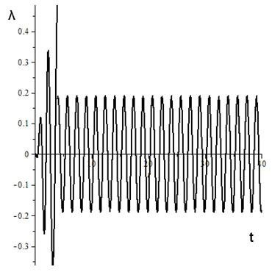

Fig. 1. Amplitude of liquid rise in a cylindrical tank λ – amplitude of liquid rise, m; t is time, p.

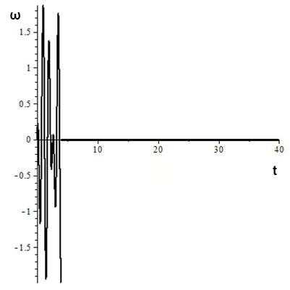

Fig. 2. Seismic acceleration from an earthquake ω – seismic acceleration, Hz ; t is time, p.

The liquid in the tank rises by 40 cm, which can lead to liquid splashing . If the tank is completely filled with liquid, this will lead to excessive pressure on the tank cap. At t = 4 s, amplitude λ=2 m, ω=2 Hz . Which corresponds to a magnitude 6 earthquake with an epicenter 200 meters away.

**Literature:**

1. Tsybulnyk S. O. Improvement of means of functional diagnostics and protection of reservoirs based on simulation modeling [Text]: autoref . Dis . ... candidate technical Sciences: 05.11.13 / Tsybulnyk Serhiy Oleksiyovych; National technical University of Ukraine "Kyiv Polytechnic Institute". - Kyiv, 2016. - 27 p.
2. Garbuz, S.V. Increasing the environmental safety of the process of ventilation of tanks with oil products [Text]: abstract ... candidate . technical Sciences, specials.: 21.06.01 - ecological safety / S.V. Pumpkin. - Sumy: Sumy State University , 2018. - 23 p.
3. Serikova O. M., Strelnikova O. O. Impact of tanks for storing poisonous and flammable liquids on the environment. Modern technologies in industrial production: materials and program of the VII All-Ukrainian scientific and technical conference (Sumy, April 21–24, 2020) pp. 238-239.